Contest Purpose:
To have our audience (customers) participate and celebrate with AWG in our 25th anniversary year by directly telling and showing the impact of AWG’s goal of empowering a better world.

Contest Idea:
- Customers will be asked to submit photos and information about their projects that have AWG product on site or installed.
- The contest will work like a raffle and every engagement earns a submission into the draw for the grand prize
- Submission works in the following flow:
  - 1 photo of AWG product on the site = 1 submission
  - 1 photo of AWG product on the site and description of the project (location, solar/wind/BESS/data center, etc) = 2 submissions
  - 1 photo of AWG product on the site, description of the project and a valid testimonial on AWG/how we empower them (cannot just be “they’re good people to work with”) = 3 submissions
- The contest will run effective immediately until 12/31/26, winner to be notified in January 2027
- Guidelines:
  - Submissions need to include name, email, company, title of the submitter
  - Photo is the only mandatory field for the submission, the description and testimonial are optional but will count towards more entries into the contest
  - For the description, the submitter needs to indicate if it’s wind, solar, BESS, data center, etc.
  - We will allow multiple entries per company per project
Support we need:
- Creating a landing page where customers can submit photos, descriptions and testimonial, plus applicable legal T&Cs of the contest and an acknowledgement that we can use their submission even if they don’t win the prize
- Need legal involved to create T&Cs
- A way of tracking submissions and reviewing the content
- A confirmation message either on screen or emailed to the submitted that we received their entry
- Sales needs to be having constant communications about this and not let it slip through the cracks. This is our one opportunity to get content like this.

The Grand Prize:
A golf package + weekend at the JW Turnberry Resort & Spa in Aventura, as well as an exclusive dinner with AWG somewhere in Miami.
This is enticing based on activity and location. The goal with a prize like this is to maximize engagement and participation among our customers.
- Budget is $10,000 for the customer contest
- We estimate:
  - 3x1000 flights = $3000
  - 2 nights x700 at JW for 3 rooms = $4200
  - Meals = $1000
  - Taxi/Uber = $500
  - Total $8700 ($10,000 to be safe)

What AWG Gets in Return:
We are getting images of our product in the field and knowledge of the end-use directly from our customers around the country, instead of doing a marketing shoot at numerous sites and spending more budget.
This is also showing a larger impact nationwide.
We’re getting feedback and testimonials that have been tough to get through surveys.

Contest Communications:
- Sales team + project managers engaging with every customer interaction to make sure customers photograph product on site and submit it to the contest
  - This would be a point of discussion every two weeks at our meetings
- Flyers will be printed and handed out in the meeting room at events to customers, and left on displays for customers to take (all exhibits)
- E-Blast and LinkedIn post once the anniversary content begins rolling out?
- Have it be communicated on the homepage of our website (carousel and a tile on its own), highlighted on the anniversary webpage and have its own landing page
- Is there a way to incorporate a flyer with the paperwork the site receives when they have our products delivered?

Contest Webpage:
Have enticing descriptions + CTA at the top.
Maybe split the submission part into 3 columns (something like below, but not exactly):
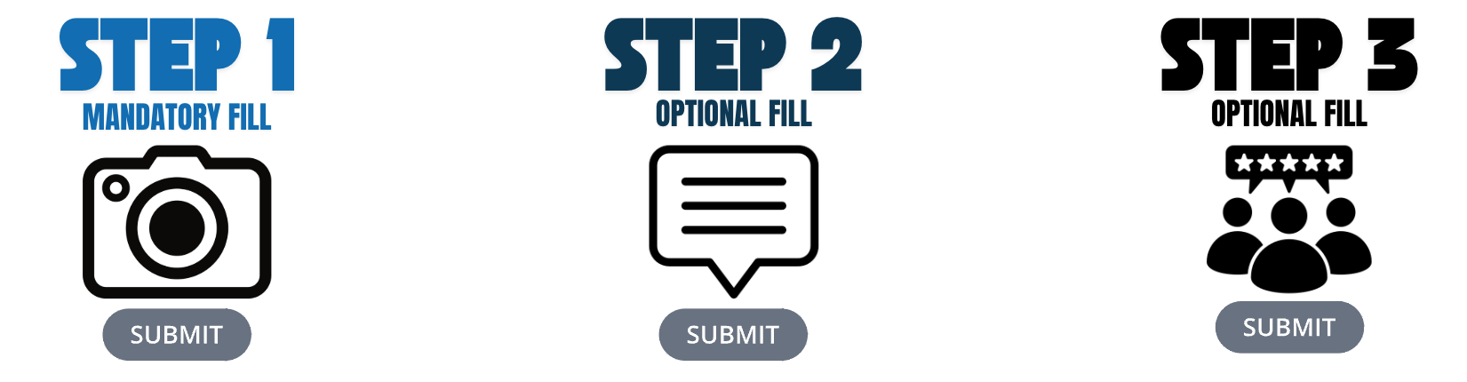
For submission purposes, we will also need mandatory field boxes for customers to fill out, like name, title, company, email address, telephone number, project name, company name, etc.
Include T&Cs (depending on length) maybe in a scrolling text box at the bottom. Have the “I acknowledge the terms and conditions” button underneath the text box, and final “Confirm” or “Submit” button at the bottom, then they can get an email confirmation that their submission has been received.

